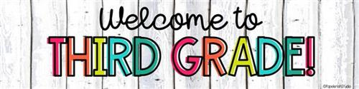

Dear Third Grade Families,

WELCOME TO THIRD GRADE! My name is Mrs. Victoratos and I am your child’s ELA and Social Studies teacher for the 2024-2025 school year. This is my seventh year teaching at Forest Street Community School and I am so happy to have you and your child as a part of our 3-1 and 3-2 classrooms! The first two weeks of the new school year are filled with many new and exciting learning experiences. Third grade is a fantastic year full of learning and growing. I care a lot about my students and it is my job to help students learn in a safe and enriching environment. In our classroom we work as a team. All students are expected to adhere to the rules and expectations that we will discuss in class. All students will be connected to the Class Dojo, where I will communicate assignments, events etc.. Please sign up to keep connected with what is happening in our classroom! Here on my webpage you can find all of the resources that we use in the classroom through CLEVER. I have also posted links to other helpful websites that your child may use. If you have any questions or concerns, feel free to reach me by email at bilicana@orange.k12.nj.us I am looking forward to a great year!

Sincerely,

Mrs. Victoratos